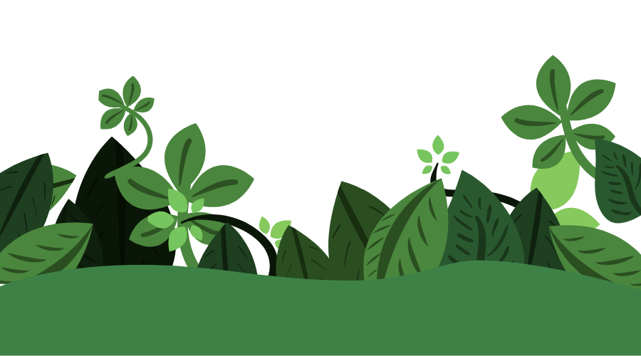
DC Area Plants

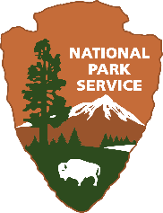  C&O Canal National Historical Park | 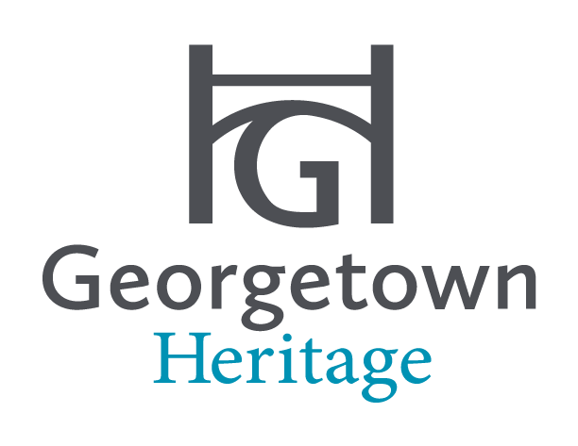

Table of Contents
Welcome to Your National Historical Park 3
Flowers Along the Towpath 4
Native Pollinators: Flowers 7
Native Pollinators: Trees and Shrubs 13
2015 Superintendent’s Compendium 16
References and Resources 17

Welcome to Your National Historical Park  Explore a diverse range of flowers, shrubs, and trees that call the 184.5 miles of the C&O Canal National Historical Park home! As you bike, hike, and enjoy the towpath, make sure to take the time to “smell the roses” and reflect on your beautiful natural surroundings.  Plan your visit – Keep this guide handy during your next outdoor adventure. Check out the C&O Canal Plan Your Visit website for important information prior to visiting the park. See the References and Resources section for more information and details about the nature you see.  Contents – This guide includes a sample of the various species of flowers, trees, and shrubs throughout DC. Although this is not a comprehensive field guide, it provides information on a variety of plants you may see in the park or in your neighborhood. The sections are organized by various locations along the C&O Canal with reference sections.  Acknowledgements and Special Thanks – This guide was created in collaboration with Georgetown Heritage, the non-profit organization helping restore, revitalize, and interpret the mile-long section of the C&O Canal in Georgetown, Washington, DC. Pictures are public domain images and retrieved from Wikimedia Commons under the Creative Commons license. |  | Engage your senses – Look up, down, and all around you. Focus on a flower, tree, or plant you have never seen. What colors do you see? Observe the different parts of the plant. What are the size and shape differences among the various flowers and trees? What makes these plants unique?  Leave No Trace – Pack in, pack out! The C&O Canal is a trash free park. Trash should be packed up and taken out of the park. Learn more about Leave No Trace and how to recreate responsibly in your National Park.  Protect Your Park – Take a picture, not a plant! Please do not take pick any flowers, plants, leaves, or take home any part of nature from the Park. With your help, we can preserve your C&O Canal for generations to come.
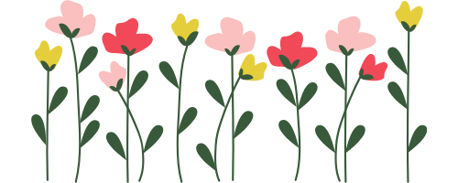

Flowers Along the Towpath
When you walk the towpath of the C&O Canal, you can find a diverse range of plants and flowers. Some plants grow closer to the ground, others rise high, or hang around the trees. Try to spot some of these plants and flowers as you visit a new area of the towpath. Take a picture to remember your adventure! Take time to think about what you see around you. Use the questions below to reflect on your surroundings.
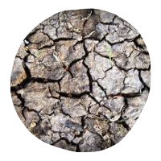  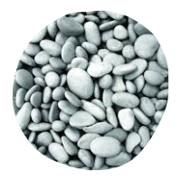  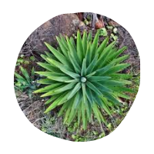  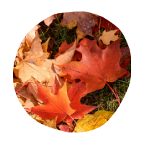  Look up, down, and all-around you! What colors, shapes, and textures do you see? | 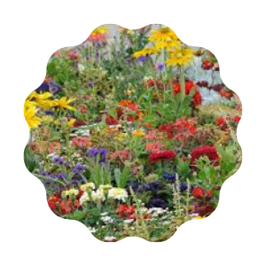  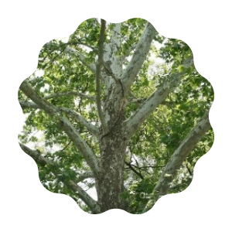  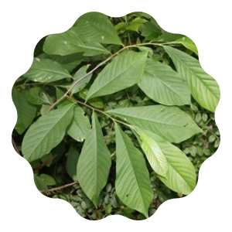  How many different types of flowers and trees can you spot? Which plants are most in abundance?
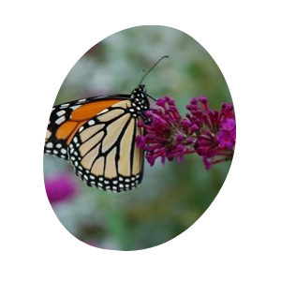  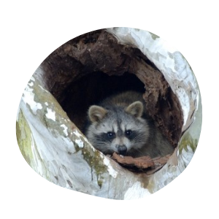  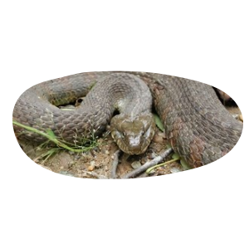  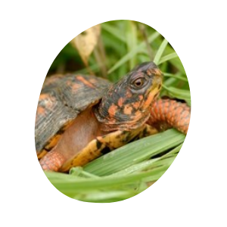  What insects or animals do you see around these plants?  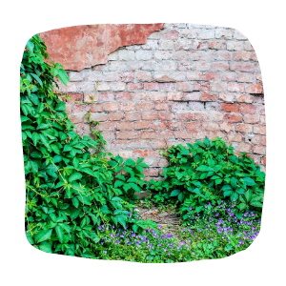  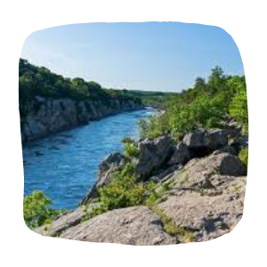 | What are the plants/flowers close to? Buildings? Water bodies? The towpath?

Spiderwort  Tradescantia virginiana  Near milepost 14  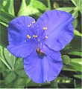 |  | Bluets  Houstonia caerulea  Near milepost 11  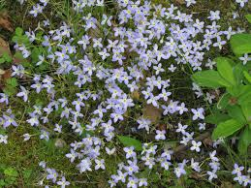 |  | Princess Tree  Paulownia tomentosa  Near Tidelock  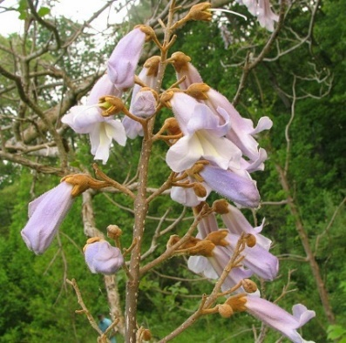
Bulbous Buttercup  Ranunculus bulbosus  Near milepost 6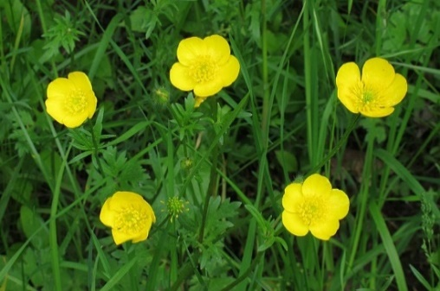 |  | Virginia Waterleaf  Hydrophyllum virginianum  Near milepost 3  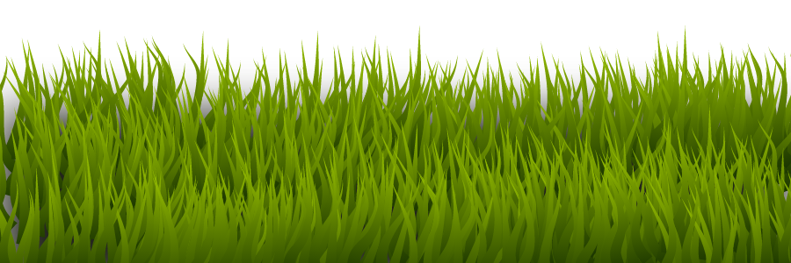  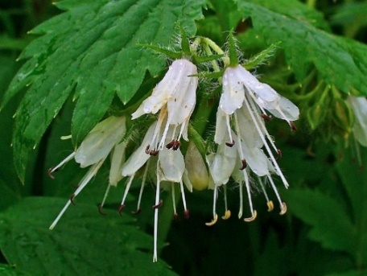
Native Pollinator Plants
Native plants are plants that naturally occur in a specific region, state, or habitat. Native plants are important to their local habitats and an important source of food for insects and animals. Native pollinator plants attract a wide variety of pollinators including bees, butterflies, birds, moths, bats, beetles, flies, and more.
How do native pollinator plants help our environment?
The native plants you will see below all play an important role in nature. These special plants help attract pollinators needed for growing vegetable gardens and fruit trees, require little water to thrive, and reduce stormwater runoff. Native pollinator plants also help better air quality and boosts the variety of plant and animal species in our environment.
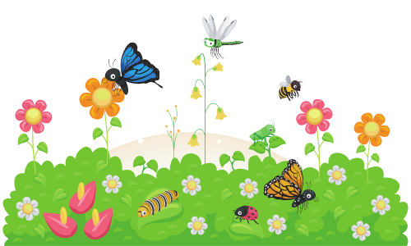
Use this guide to help identify native pollinator plants in your neighborhood, around your school, or at your local park. Research your local garden centers and see if they have some of these plants you can grow in your own garden!

Native Pollinators: Flowers
Swamp Milkweed  Asclepias incarnata  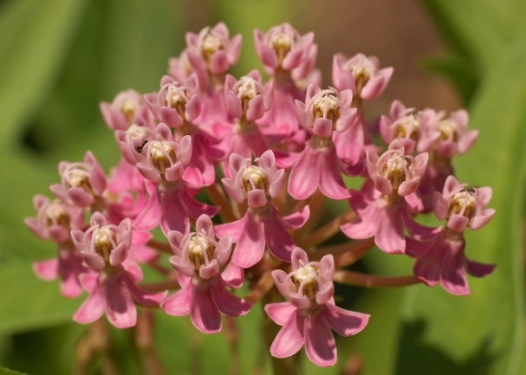 |  | Common Milkweed  Asclepias syriaca  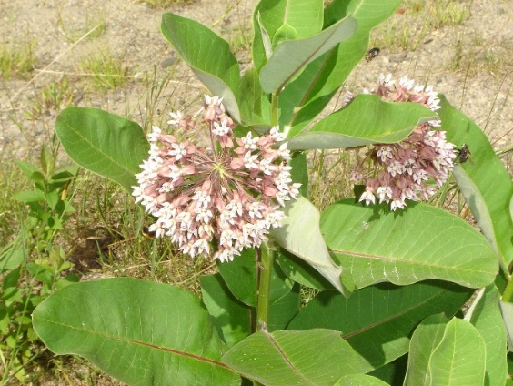 |  | Yellow Wild  Baptisia tinctoria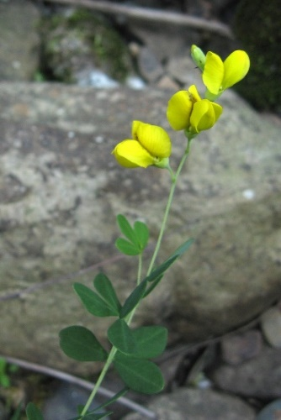

Partridge Pea  Chamaecrista fasciculata  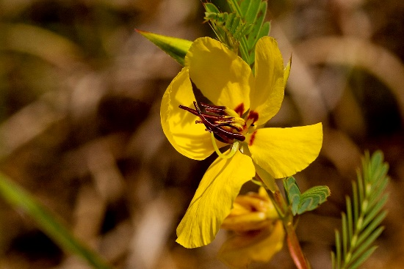 |  | Showy Tick  Desmodium canadense  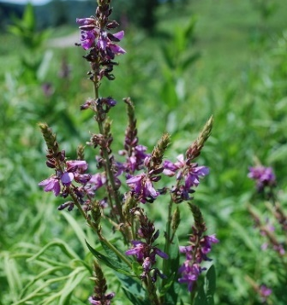 |  | Three-nerved Joe-Pye Weed  Eupatorium dubium  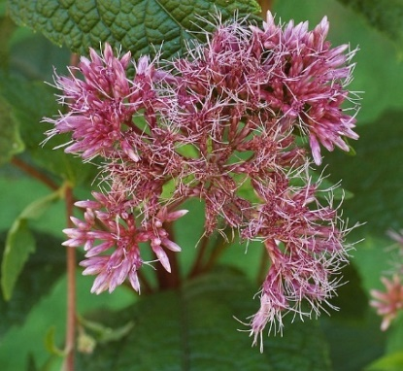

Common Boneset  Eupatorium perfoliatum  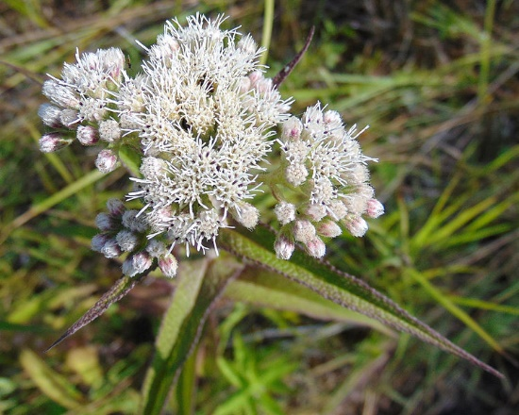 |  | Purple-node Joe-Pye Weed  Eupatorium purpureum  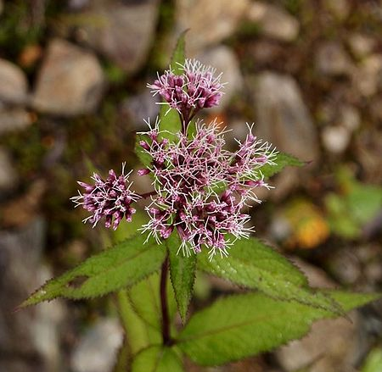 |  | Giant Sunflower  Helianthus giganteus  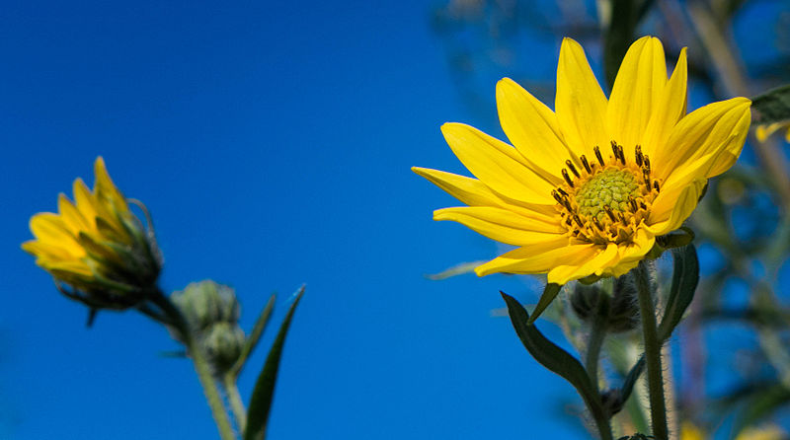

Ox-eye Sunflower  Heliopsis helianthoides  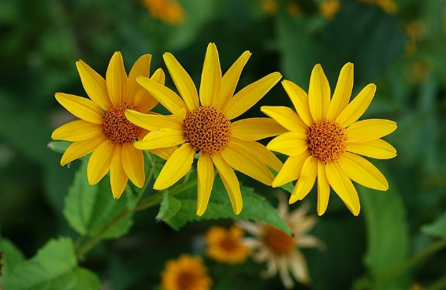 |  | Round-head Bush-Clover  Lespedeza capitata  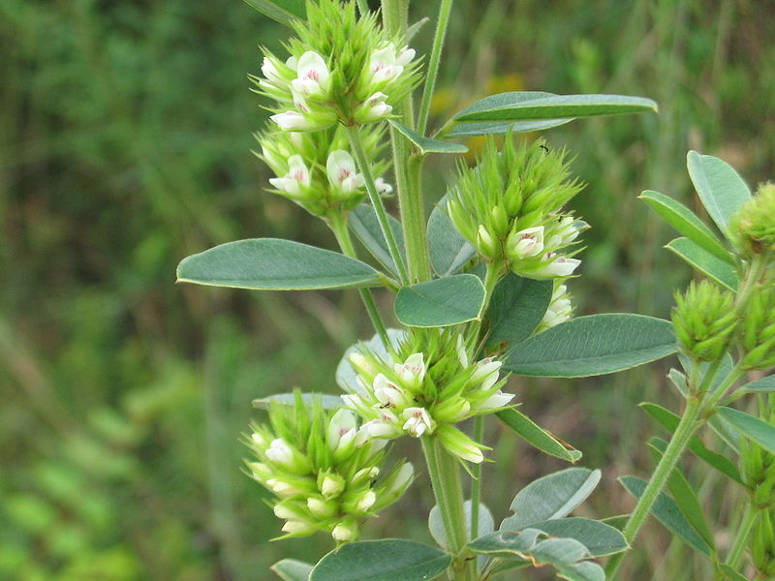 |  | Dense Blazing-star  Liatris spicata  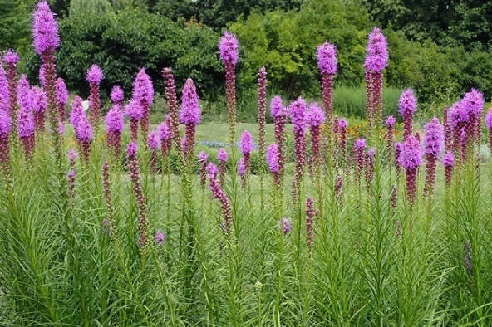

Shaggy Blazing-star  Liatris graminifolia |  | Great Blue  Lobelia siphilitica  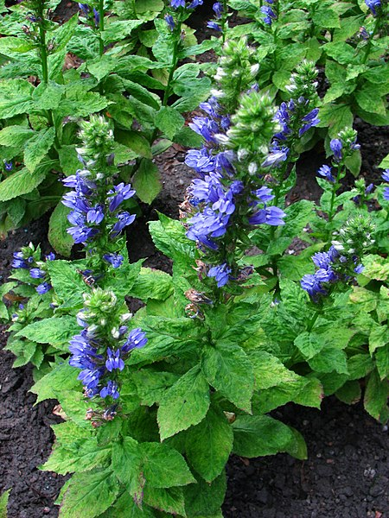 |  | Wild Blue  Lupinus perennis  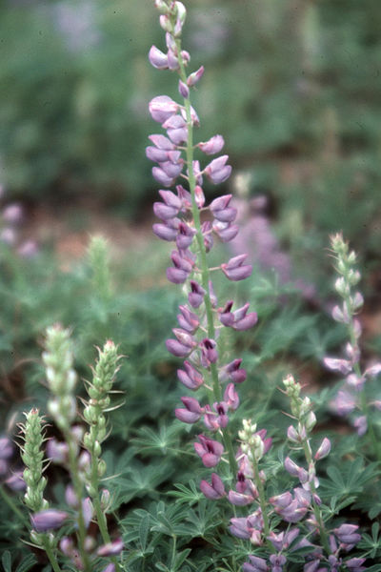

Wild Bergamot  Monarda fistulosa  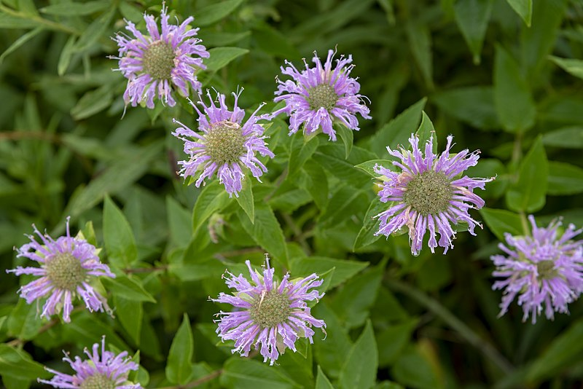 |  | Spotted Horsemint  Monarda punctata |  | Beardtongue  Penstemon digitalis  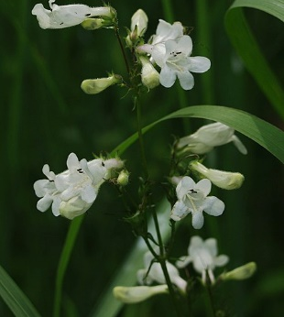

Bigleaf Mountain Mint  Pycnanthemum muticum  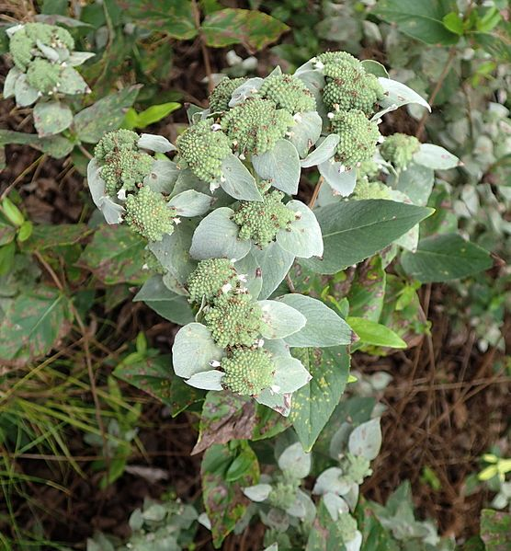 |  | Common Mountain Mint  Pycnanthemum virginianum  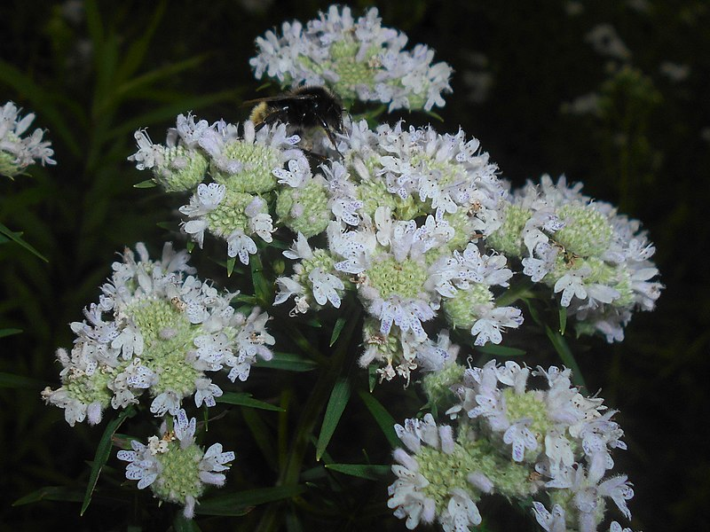 |  | Black-Eyed Susan  Rudbeckia hirta  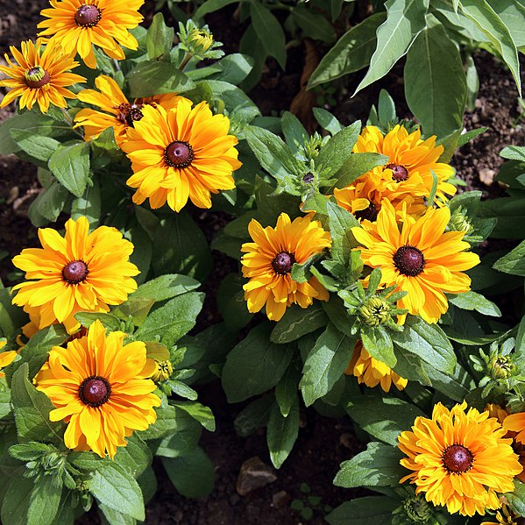

Coneflower  Echinacea angustifolia  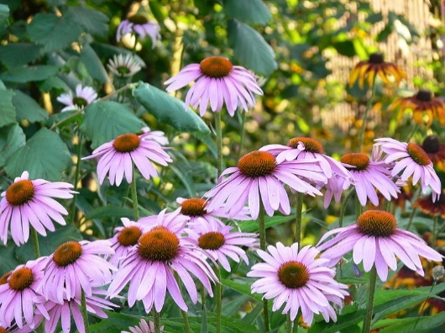 |  | Canada Goldenrod  Solidago canadensis  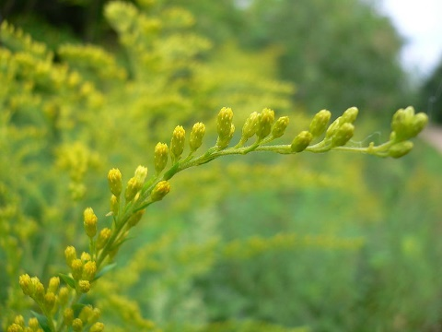 |  | Early Goldenrod  Solidago juncea  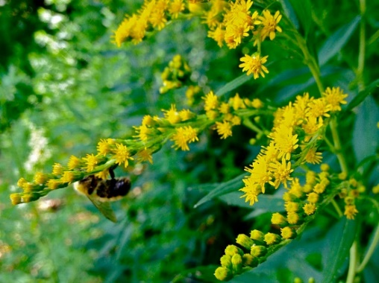

New England Aster  Symphyotrichum novae-angliae  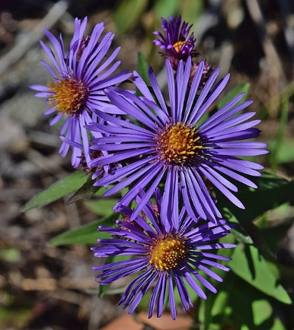 |  | Hairy Heath Aster  Symphyotrichum pilosum  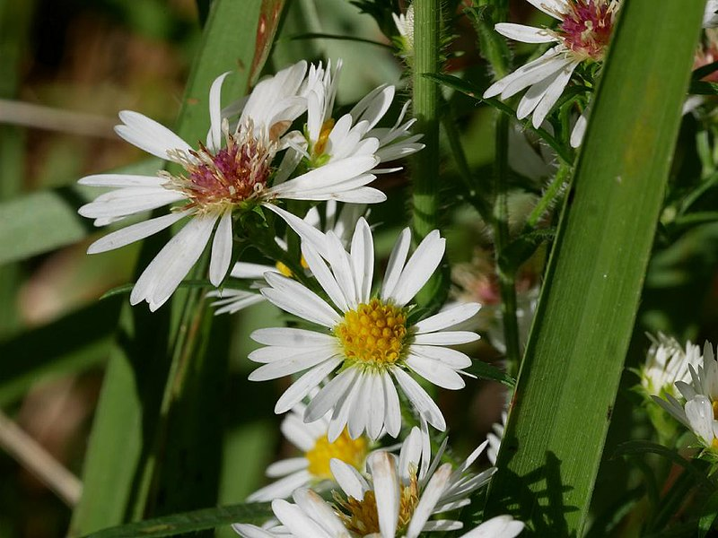 |  | Virginia Wild rye  Elymus virginicus  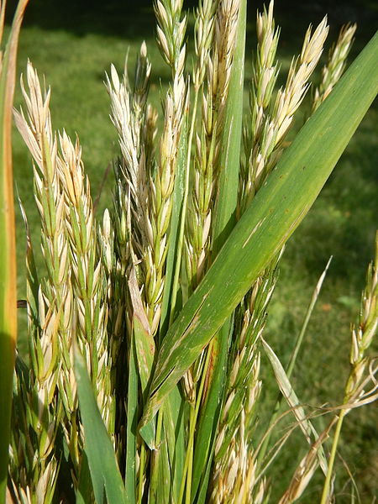

Blue Vervain  Verbena hastata  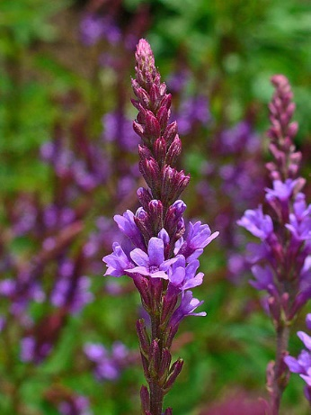 |  | New York Ironweed  Vernonia noveboracensis |  | Golden Alexanders  Zizia aurea  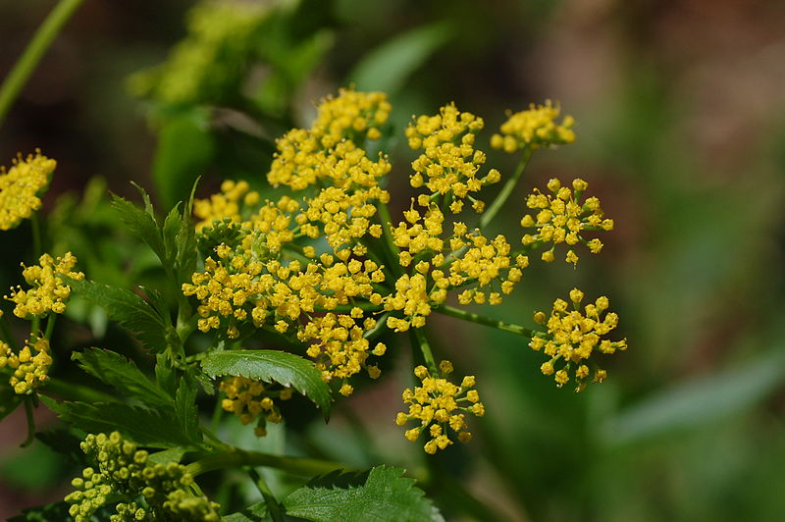

Big Bluestem  Andropogon gerardii  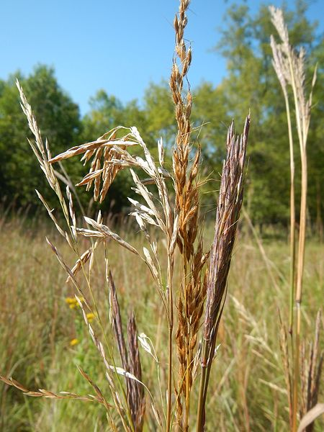 |  | Switch Grass  Panicum virgatum  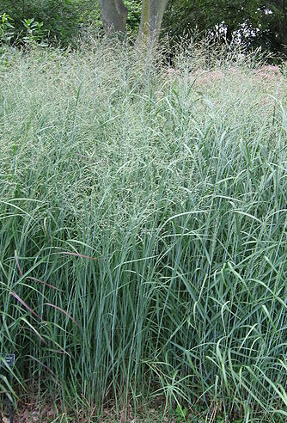 |  | Little Bluestem  Schizachyrium scoparium  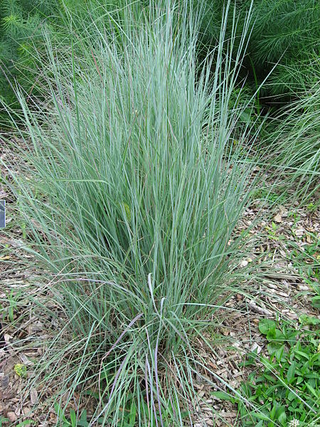

Indian Grass  Sorghastrum nutans  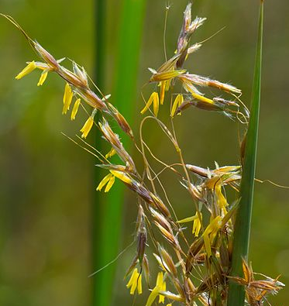 |  | Eastern Gamagrass  Tripsacum dactyloides  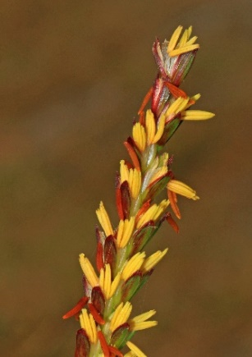 |  | Canada Wild rye  Elymus canadensis  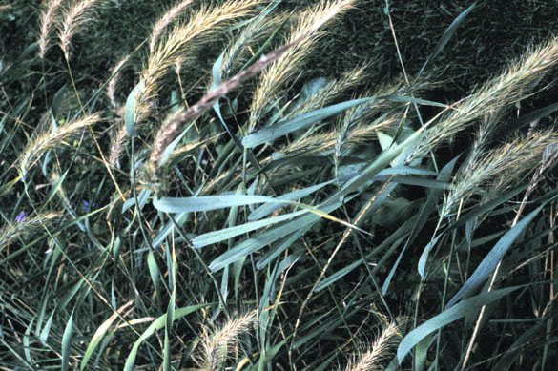

Native Pollinators: Trees and Shrubs
Red Maple  Acer rubrum  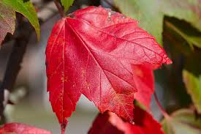 |  | Black Cherry  Prunus serotina  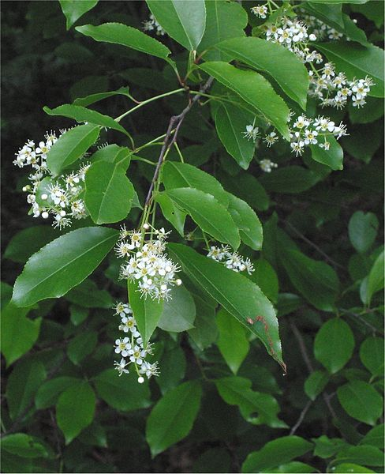 |  | Allegheny Serviceberry  Amelanchier laevis  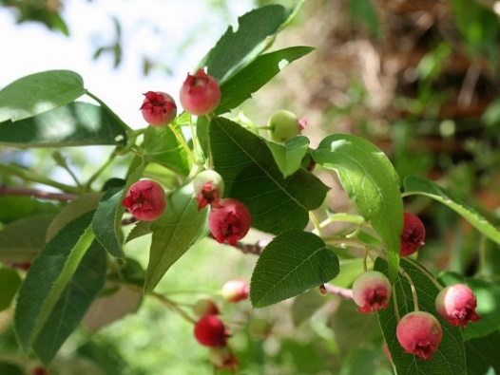

Buttonbush  Cephalanthus occidentalis  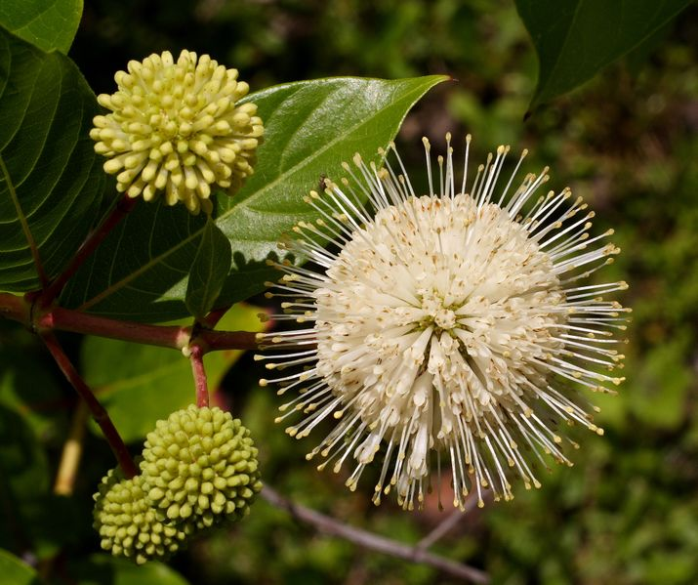 |  | Winterberry Holly  Ilex verticillate  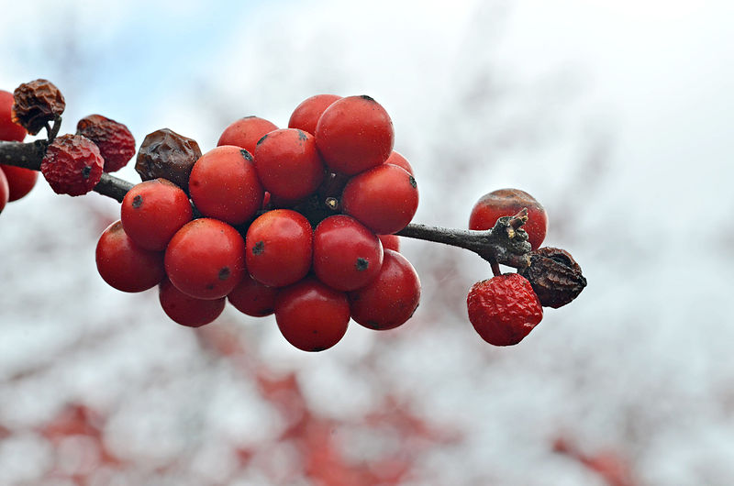 |  | Pawpaw  Asimina triloba  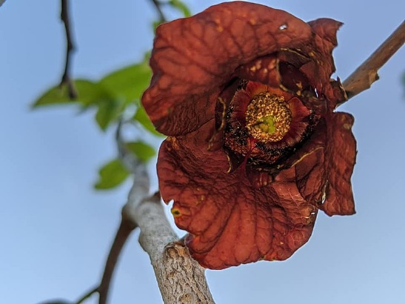

Virginia Sweetspire  Itea virginica  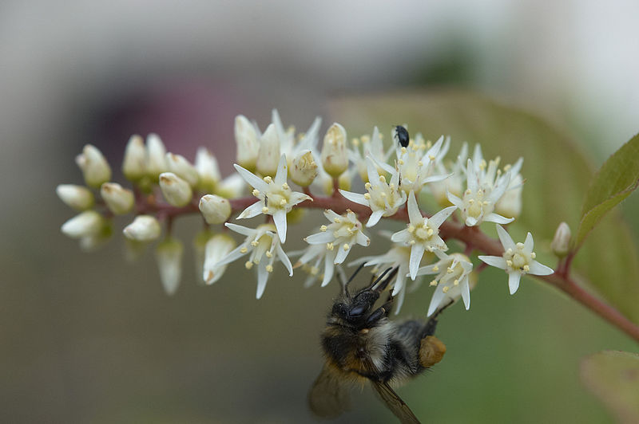 |  | Flowering dogwood  Cornus florida  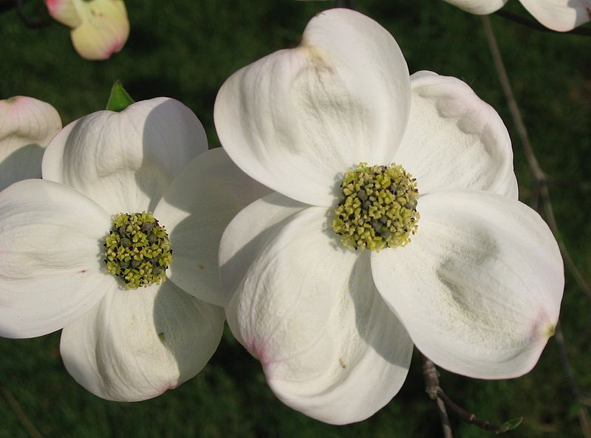 |  | Silky dogwood  Cornus amomum  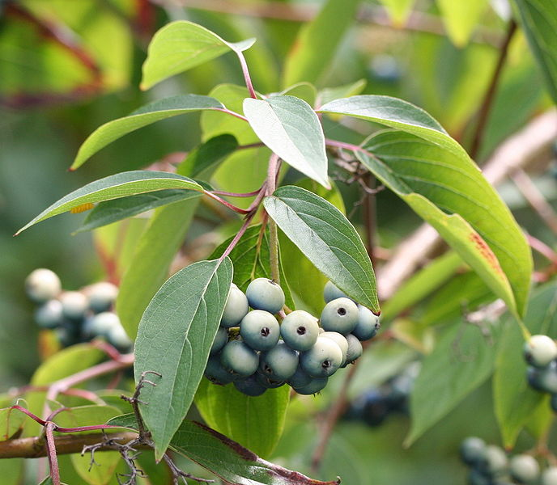

Redbud  Cercis Canadensis  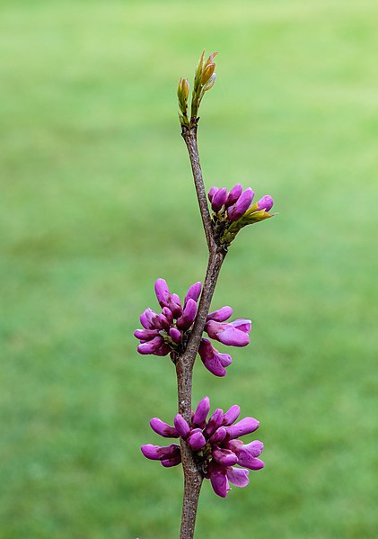 |  | Mountain Laurel  Kalima latifolia  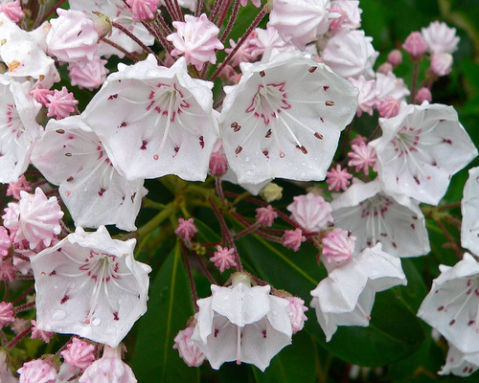 |  | Witch hazel  Hamamelis virginiana  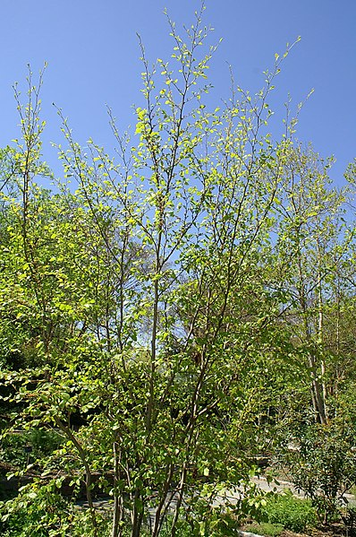

Spicebush  Linder benzoin  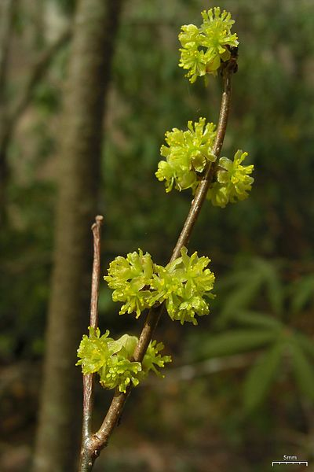 |  | Arrowwood viburnum  Viburnum dentatum  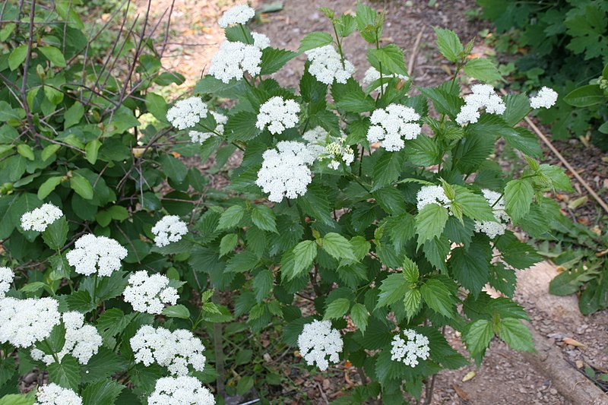 |  | Blackhaw viburnum  Viburnum prunifolium  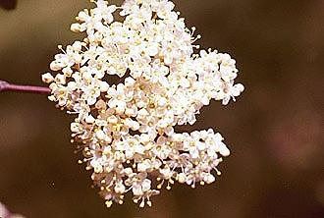
Highbush Blueberry
Vaccinium corymbosum
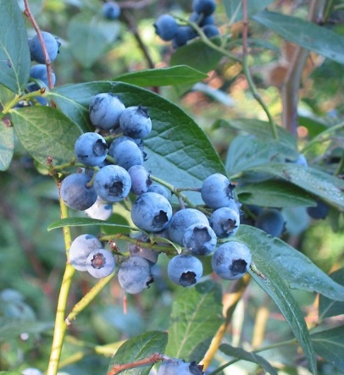
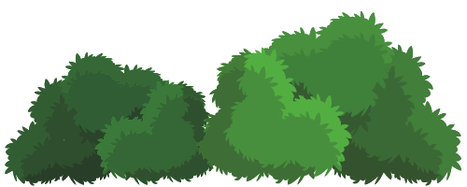

2015 Superintendent’s Compendium
Click here for a full copy of the C&O Canal National Historical Park 2015 Superintendent’s Compendium, also found in the Code of Federal Regulations Title 36, Chapter 1.7 (b).
In Section 2.1(c)(1) of the 2015 Superintendent’s Compendium, it reads:
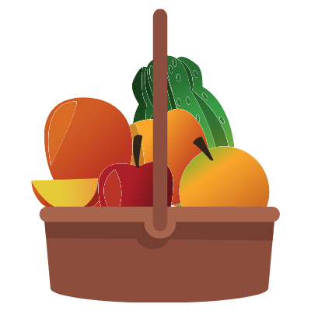
Edible fruits, nuts, berries, and mushrooms may be gathered by hand for personal use or consumption. Commercial use is prohibited. Removal of fruits, nuts, berries, and mushrooms cannot disturb the remainder of the plant. Possession of plant fruits, nuts, berries, and mushrooms are limited to the following quantities:
Fruit/Nut/Berry | Daily per Person Limit
Walnuts | 1 Bushel
Hickory Nuts (sp.) | 1 Bushel
Acorns (Oak sp.) | 1 Bushel
Apples | 1 Bushel
Cherries | ½ Gallon
Blackberries | ½ Gallon
Raspberries | ½ Gallon
Dewberries | ½ Gallon
Strawberries | ½ Gallon
Huckleberry species | ½ Gallon
Elderberries | ½ Gallon
Wine berries | ½ Gallon
Paw Paws | ½ Gallon
Mushroom species | ½ Gallon

Visit the C&O Canal National Historical Park website to Plan Your Visit.

References and Resources
Chesapeake and Ohio Canal National Historical Park | Wildflower Information Page
To view more pictures and learn more information about wildflowers at the C&O Canal, make sure to visit the Wildflower Information Page on the Park website.
The C&O Canal Association | Wildflower Guide
This guide uses information from the C&O Canal’s partner organization, the C&O Canal Association, resource document on wildflowers found along the Canal.
NPSpecies | Species List
Interested in learning even more about the plants found at the C&O Canal National Historical Park?! Click here to view the full species list provided by the National Park Service’s Integrated Resource Management Applications (IRMA) Portal
DC.Gov | Community Gardens
Learn how to find a community garden near you! Find volunteer opportunities, planting resources, and links to local urban farms. Website includes community gardens organized by ward and contact information for getting involved.

Department of Energy & Environment (DOEE) | Native Plants
What’s a pollinator plant? Have you ever visited a community garden? Answer these questions and learn more about the native plants to the DC area from the DOEE website.
Wikimedia Commons | Main page
Public domain images of various flowers were obtained from Wikimedia Commons, a website used to search for public domain and freely licensed educational media content, under the Creative Commons license.

