Plants in the Park

Chesapeake and Ohio Canal National Historical Park

Maryland and Washington, DC

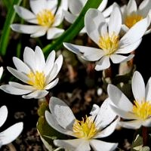
Photo by NPS

The National Park Service
US Department of Interior
Table of Contents
Welcome to Your National Historical Park 3
Town Creek to Stickpile (Mile 162.1 – 149.4) 5
Stickpile to Cacapon Junction (Mile 149.4 – 133.6) 5
Cacapon Junction to Hancock (Mile 133.6 to 124.1) 6
McCoy’s Ferry to Williamsport (Mile 110.4 – 99.7) 7
Williamsport to Dam 4 (Mile 99.7 – 84.4) 8
Brunswick to Indian Flats (Mile 54.0 – 42.4) 9
Indian Flats to Sycamore Landing (Mile 42.4 – 27.2) 10
Sycamore Landing to Great Falls (Mile 27.2 – 14.3) 10
Great Falls to Tidelock (Mile 14.3 – 0.0) 11
Blooming Periods 13
2015 Superintendent’s Compendium 14
References and Resources 15

Welcome to Your National Historical Park  Explore a diverse range of flowers, shrubs, and trees that call the C&O Canal home with this guide! As you bike, hike, and enjoy the towpath, make sure to take the time to “smell the flowers” and reflect on your beautiful natural surroundings.  Plan your visit – Keep this guide handy during your next outdoor adventure. Check out the C&O Canal Plan Your Visit website for important information prior to visiting the park. See the References and Resources section for more information and details about the nature you see.  Contents – This guide includes a sample of the various species of trees and wildflowers found in Maryland and DC. Although this is not a comprehensive field guide, it provides information on a variety of plants you may see in the park. The sections are organized by various locations along the C&O Canal with reference sections.  Acknowledgements and Special Thanks – Content and images in this guide was adapted from the C&O Canal Association Wildflower Guide. Picture credits are noted in captions. Public domain images were retrieved from Wikimedia Commons under the Creative Commons license. |  | Engage your senses – Look up, down, and all around you. Focus on a flower, tree, or plant you have never seen. What colors do you see? Observe the different parts of the plant. What are the size and shape differences among the various flowers and trees? What makes these plants unique?  Viewing nature – Make sure to refer to the Blooming Period table to see which flowers might be in season throughout the park.  Leave No Trace – Pack in, pack out! The C&O Canal is a trash free park. Trash should be packed up and taken out of the park. Learn more about Leave No Trace and how to recreate responsibly in your National Park.  Protect Your Park – Take a picture, not a plant! Please do not take pick any flowers, plants, leaves, or take home any part of nature from the Park. With your help, we can preserve your C&O Canal for generations to come.
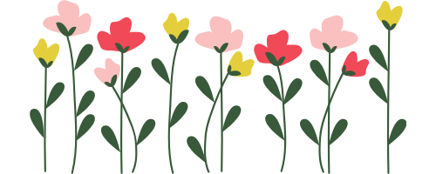
Cumberland to Spring Gap (Mile 184.5 to 173.4)
Bloodroot  Scientific name: Sanguinaria canadensis  Can grow to 10 inches, root has a reddish sap  Found near mileposts 184-180  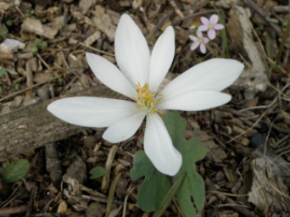  Figure 1 – Photo of Bloodroot provided by the C&O Canal Association. Photo taken by Marj Richman. | Periwinkle  Scientific name: Vinca minor  Mat-forming plant, can grow to 8 inches  Found near milepost 178  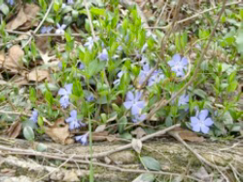  Figure 2 -- Photo of Periwinkle provided by the C&O Canal Association. Photo taken by Pat Hopson. | Gill-over-the-ground  Scientific name: Glechoma hederacea  Many wild bees collect pollinate this plant  Found near mileposts 175 – 173  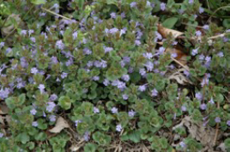  Figure 3 -- Photo of Gill-over-the-ground provided by the C&O Canal Association. Photo taken by Jim Heins.
Dogtooth Violet or Trout Lily  Scientific name: Erythronium americanum  Can grow to 10 inches (25 centimeters)  Found near milepost 175  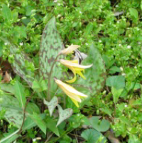  Figure 4 -- Photo of Dogtooth Violet courtesy of the C&O Canal Association. Photo taken by Marion Robertson. | Cutleaf Toothwort  Scientific name: Dentaria laciniate  Attracts butterflies and eaten by mice  Found near milepost 175  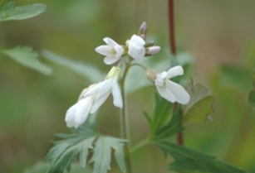  Figure 5 -- Photo of Cutleaf Toothwort courtesy of the C&O Canal Association. Photo taken by Jim Heins.

Town Creek to Stickpile (Mile 162.1 – 149.4)
Common Mullein  Scientific name: Verbascum Thapsus  Hairy biennial plant that can grow over 6 feet  Found near milepost 161  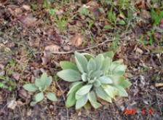  Figure 6 -- Photo of Common Mullein courtesy of the C&O Canal Association. Photo taken by Chris Cerniglia. | Coltsfoot  Scientific name: Tussilago farfara  Found near Cumberland end of Paw Paw tunnel; looks like common Dandelion  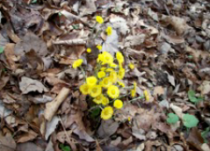  Figure 7 -- Photo of Coltsfoot courtesy of the C&O Canal Association. Photo taken by Betsy Williamson. | Virginia Bluebells  Scientific name: Mertensia virginica  Trumpet shape perennial; grows 1-2' tall  Found near milepost 149.4, 132  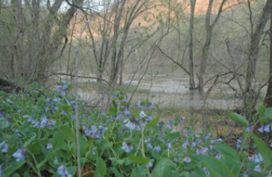  Figure 8 -- Photo of Virginia Bluebells courtesy of Jim Heins from the C&O Canal Association.

Stickpile to Cacapon Junction (Mile 149.4 – 133.6)
Birdfoot Violet  Scientific name: Viola pedata  Leaves are bird foot shaped  Found near milepost 150.2  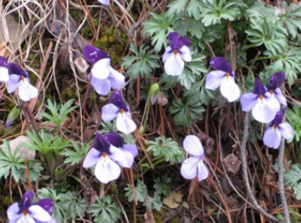  Figure 9 -- Photo courtesy of Marion Robertson of the C&O Canal Association. | Toadshade  Scientific name: Trillium sessile  Perennial; Foul smelling flower  Found near milepost 147  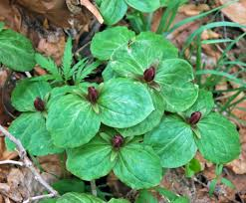  Figure 10 -- Public domain photo of Toadshade plants in a bunch. | Wild Columbine  Scientific name: Aquilegia canadensis  Fern-like plant with red and yellow flowers  Found near milepost 146.5  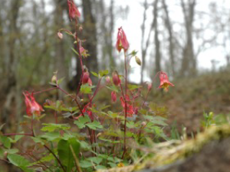  Figure 11 -- Photo courtesy of Jim Heins of the C&O Canal Association.
Jefferson Twinleaf  Scientific name: Jeffersonia diphylla  Smooth leaves and white flowers  Found near milepost 145  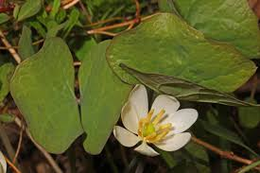  Figure 12 -- Public domain photo of the Jefferson Twinleaf. | Dutchman’s Breeches  Scientific name: Dicentra cucullaria  Cluster of small pink and white bublets  Found near milepost 141  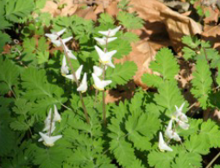  Figure 13 -- Photo of Dutchman's Breeches courtesy of Frank Wodarczyk from the C&O Canal Association. | Squirrel corn  Scientific name: Dicentra canadensis  Small yellow clustered bublets  Found near milepost 141  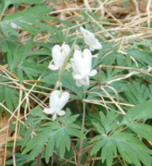  Figure 14 -- Photo of Squirrel corn courtesy of Frank Wodarczyk from the C&O Canal Association.

Cacapon Junction to Hancock (Mile 133.6 to 124.1)
Spring Beauty  Scientific name: Claytonia virginica  Low plant with loose clusters of pink or white flowers; Found near milepost 129  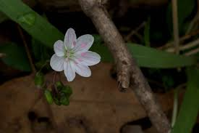  Figure 15 -- Public domain photo of the Virginia Spring Beauty. | Blue Phlox  Scientific name: Phlox divaricata  Five lilac blue petals; Can form large colonies over time; Found near milepost 127  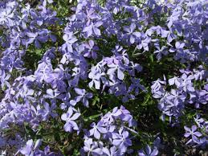  Figure 16 -- Public domain image. Cluster of Blue Phlox flowers. | Redbud  Scientific name: Cercis canadensis  Tree with a short trunk and pink flowers; Found near milepost 126  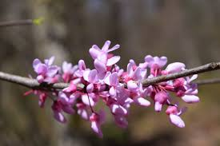  Figure 17 -- Public domain image of Redbud flowers.
Common Blue Violet  Scientific name: Viola sororia  Short-stemmed herbaceous plant with purple flower; Found near milepost 118  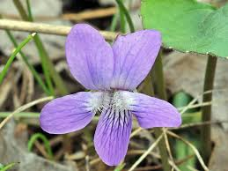  Figure 18 -- Public domain image of Common Blue Violet. | Downy Yellow Violet  Scientific name: Viola pubescens  Found in woodlands meadows; Round yellow flower; Found near milepost 118  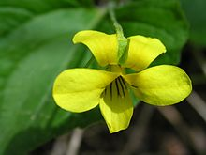  Figure 19 -- Public domain image of Downy Yellow Violet. | Skunk Cabbage  Scientific name: Symplocarpus foetidus  Low growing plant that exudes odor that attracts insects; Found near milepost 11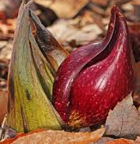  Figure 20 -- Public domain photo of Skunk Cabbage.

McCoy’s Ferry to Williamsport (Mile 110.4 – 99.7)
Wild Ginger  Scientific name: Asarum candense  Flowers are hairy and have tapered tips; Found near milepost 106  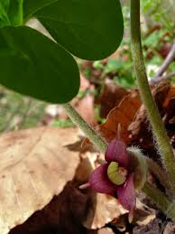  Figure 21 -- Public domain image of Wild Ginger flower. | Canadian White Violet  Scientific name: Viola canadensis  White blooms with yellow centers  Found near milepost 106  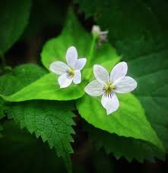  Figure 22 -- Public domain image of Canadian White Violet. | Non-native Nodding Star-of-Bethlehem  Scientific name: Ornithogalum nutans  Native to Europe; Gray to white drooping flowers; Found near milepost 106  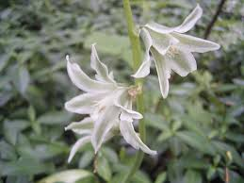  Figure 23 -- Public domain image of the non-native plant the Nodding Star-of-Bethlehem.

Williamsport to Dam 4 (Mile 99.7 – 84.4)
Star Chickweed  Scientific name: Stellaria pubera  White star-like shape blossom and ovate leaves; Found near milepost 99  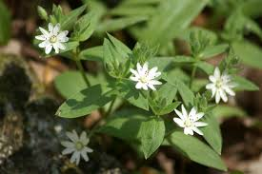  Figure 24 -- Public domain image of Star Chickweed. | Red Trillium  Scientific name: Trillium erectum  Maroon petals; Odor attracts scavenging flies for pollination; Found near milepost 99  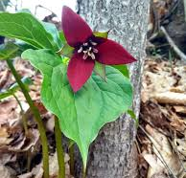  Figure 25 -- Public domain image of Red Trillium. | Marsh Speedwell  Scientific name: Veronica scutellata  Found near moist habitats; Purple-green or reddish leaves; Found near milepost 92  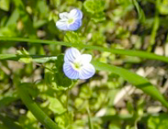  Figure 26 – Image of Marsh Speedwell flowers courtesy of Rachel Stewart of the C&O Canal Association.
Dwarf Larkspur  Scientific name: Delphinium tricorne  Stringy thin stems with flowers of shades of blue; Found near milepost 90  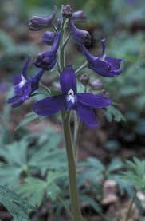  Figure 27 -- Public domain image of Dwarf Larkspur. | Non-native Dame’s Rocket  Scientific name: Hesperis matronalis  Fragrant purple-like flowers with hairy stems  Found near milepost 89  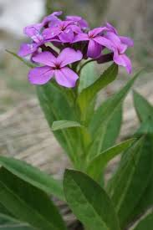  Figure 28 -- Public domain image of Dame's Rocket.

Antietam to Brunswick Campground (Mile 69.4 – 54.0)
Daisy Fleabane  Scientific name: Erigeron annuus  Yellow centers with thin white petals  Found near milepost 59  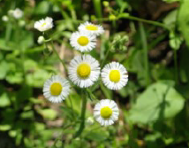  Figure 29 -- Photo courtesy of Frank Wodarczyk of the C&O Canal Association. | Dogwood  Scientific name: Cornus florida  Small trees that grow wild along the towpath  Found near milepost 59  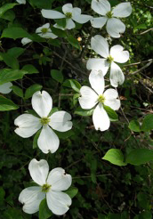  Figure 30 -- Photo courtesy of Frank Wodarczyk of the C&O Canal Association.

Brunswick to Indian Flats (Mile 54.0 – 42.4)
Celandine Poppy  Scientific name: Stylophorum diphyllum  Deep yellow flowers that bloom in patches  Found near milepost 51  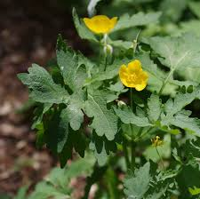  Figure 31 -- Public domain image of Celandine Poppy. | Mayapple  Scientific name: Podophyllum peltatum  White flowers and mature into a green, yellow or red fleshy fruit; Near milepost 50  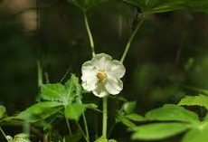  Figure 32 -- Public domain image of Mayapple. | Common Paw  Scientific name: Asimina triloba  Small tree with large green to yellow-brown fruit; Near milepost 48  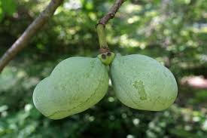  Figure 33 -- Public domain image of the Common Paw.

Indian Flats to Sycamore Landing (Mile 42.4 – 27.2)
White Phlox  Scientific name: Phlox pilosa  Lavender flower petals with long, narrow, pointed-tip leaves; Near milepost 42.4  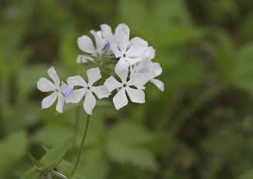  Figure 34 -- Public domain image of the White Phlox. | Grape Hyacinth  Scientific name: Muscari botryoides  Purple flowers close together and almost completely round; Near milepost 33  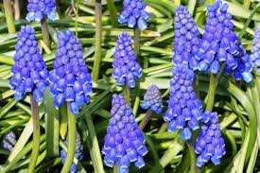  Figure 35 -- Public domain image of the Grape Hyacinth.

Sycamore Landing to Great Falls (Mile 27.2 – 14.3)
Non-native Japanese Honeysuckle  Scientific name: Lonicera japonica  Twining vine with simple oval leaves; Flowers are yellow white; Near milepost 22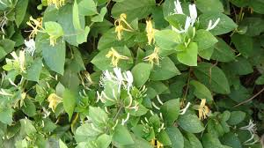  Figure 36 -- Public domain image of the Japanese Honeysuckle. | Field Chickweed  Scientific name: Cerastium arvense  Creeper plant that mats with an upright white flower; Near milepost 21  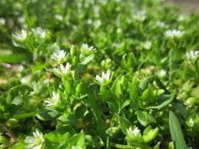  Figure 37 -- Public domain image of the Field Chickweed. | Jack-in-the-pulpit  Scientific name: Arisaema triphyllum  Three leaves growing together at the top of one long stem; Near milepost 20  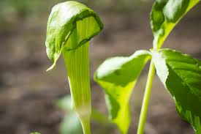  Figure 38 -- Public domain image of the Jack-in-the-pulpit.

Great Falls to Tidelock (Mile 14.3 – 0.0)
Spiderwort  Scientific name: Tradescantia virginiana  Blue purple flowers with simple leaves and tubular stems; Near milepost 14  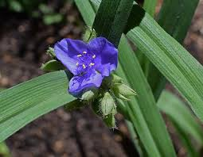  Figure 39 -- Public domain image of Virginia Spiderwort. | Bluets  Scientific name: Houstonia caerulea  Pale blue petals and yellow center; Grows well in grasses; Near milepost 11  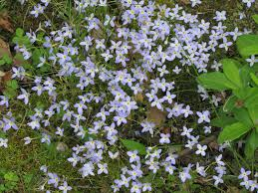  Figure 40 -- Public domain image of Bluets. | Princess Tree  Scientific name: Paulownia tomentosa  Fragrant flowers and lobed leaves on the tall tree; Near Tidelock  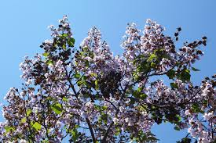  Figure 41 -- Public domain image of the Princess Tree's flowers.
Bulbous Buttercup  Scientific name: Ranunculus bulbosus  Three-lobed yellow flowers with long basal leaves; Near milepost 6  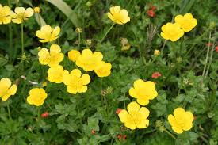  Figure 42 -- Public domain image of the Bulbous Buttercup. | Virginia Waterleaf  Scientific name: Hydrophyllum virginianum  Flowers are blue white and can be found in colonies in wooded areas; Near milepost 3  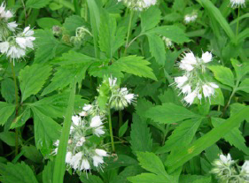  Figure 43 -- Public domain image of the Virginia Waterleaf.

Blooming Periods
Flower | Blooming Period |  | (Continued) Flower | Blooming Period
Bloodroot Sanguinaria canadensis | March – May |  | Star Chickweed Stellaria pubera | March – Mary
Periwinkle Vinca minor | March – June |  | Red Trillium Trillium erectum | April – June
Gill-over-the-ground Glechoma hederacea | April – July |  | Marsh Speedwell Veronica scutellata | May – Sept
Dogtooth Violet Erythronium americanum | April – June |  | Dwarf Larkspur Delphinium tricorne | April – May
Cutleaf Toothwort Dentaria laciniate | April – June |  | Dame’s Rocket (Non-native) Hesperis matronalis | May – July
Common Mullein Verbascum thapsus | June – September |  | Daisy Fleabane Erigeron annuus | May – Oct
Coltsfoot Tussilago farfara | March – June |  | Dogwood Cornus florida | April – May
Virginia Bluebells Mertensia virginica | March – May |  | Celandine Poppy Stylophorum diphyllum | March – May
Birdfoot Violet Viola pedate | April – June |  | Mayapple Podophyllum peltatum | April – June
Toadshade Trillium sessile | April – June |  | Common Paw Asimina triloba | April – May
Wild Columbine Aquilegia candensis | April – June |  | White Phlox Phlow pilosa | May – June
Jefferson Twinleaf Jeffersonia diphylla | April – May |  | Grape Hyacinth Muscari botryoides | April – May
Dutchman’s Breeches Dicentra cucullaria | April – May |  | Japanese Honeysuckle (Non-native) Lonicera japonica | April – July
Squirrel corn Dicentra candensis | April – May |  | Field Chickweed Cerastium arvense | April – July
Spring Beauty Claytonia virginica | March – May |  | Jack-in-the-pulpit Arisaema triphyllum | April – June
Blue Phlox Phlox divaricata | April – June |  | Spiderwort Tradescantia virginiana | April – July
Redbud Cercis canadensis | April – May |  | Bluets Houstonia caerulea | April – June
Common Blue Violet Viola sororia | March – June
Downy Yellow Violet Viola pubescens | April – June
Wild Ginger Asarum candense | April – May
Canadian White Violet Viola canadensis | April – July
Nodding Star-of-Bethlehem (Non-native) Ornithogalum nutans | April – May

2015 Superintendent’s Compendium
For a full copy of the C&O Canal National Historical Park 2015 Superintendent’s Compendium follow the link: https://www.nps.gov/choh/learn/management/upload/CHOH-compendium-2016.pdf
In Section 2.1(c)(1) of the 2015 Superintendent’s Compendium, it reads:
Edible fruits, nuts, berries, and mushrooms may be gathered by hand for personal use or consumption. Commercial use is prohibited. Removal of fruits, nuts, berries, and mushrooms cannot disturb the remainder of the plant. Possession of plant fruits, nuts, berries, and mushrooms are limited to the following quantities:
Fruit/Nut/Berry | Daily per Person Limit
Walnuts | 1 Bushel
Hickory Nuts (sp.) | 1 Bushel
Acorns (Oak sp.) | 1 Bushel
Apples | 1 Bushel
Cherries | ½ Gallon
Blackberries | ½ Gallon
Raspberries | ½ Gallon
Dewberries | ½ Gallon
Strawberries | ½ Gallon
Huckleberry species | ½ Gallon
Elderberries | ½ Gallon
Wine berries | ½ Gallon
Paw Paws | ½ Gallon
Mushroom species | ½ Gallon

References and Resources
Chesapeake and Ohio Canal National Historical Park | Wildflower Information Page
To view more pictures and learn more information about wildflowers at the C&O Canal, make sure to visit the Wildflower Information Page on the Park website.

The C&O Canal Association | Wildflower Guide
This guide uses information from the C&O Canal’s partner organization, the C&O Canal Association, resource document on wildflowers found along the Canal.

NPSpecies | Species List
Interested in learning even more about the plants found at the C&O Canal National Historical Park?! Click here to view the full species list provided by the National Park Service’s Integrated Resource Management Applications (IRMA) Portal

Wikimedia Commons | Main page
Public domain images of various flowers were obtained from Wikimedia Commons, a website used to search for public domain and freely licensed educational media content.

